Card Game

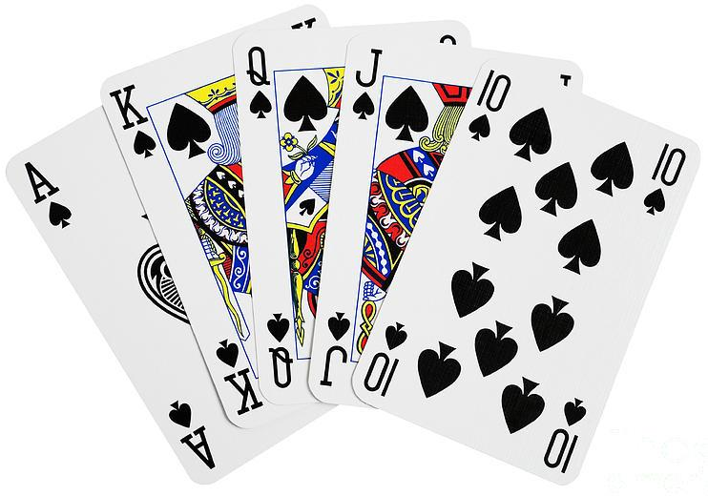

Problem Statement

* Given a deck of cards, develop a console application.
* User playing the game should have three options
  + Play a card
    - When user plays a card – the application must throw the card i.e. the card at the at the top of a shuffled deck is shown.
    - The card played should be in a random order
    - The card once played would not appear again while playing
  + Shuffle the deck
    - User can shuffle the cards in hand (cards which are not played yet)
  + Restart the game
    - Mid way while playing, user may decide to play again.
    - Restarting a game will have all the 52 cards again in hand.

Evaluation Criteria

* Code Clarity, ease of understanding
* OOPs fundamentals, how to extend your solution to other applications
* Code commenting
* Code maintainability, how easy is it to maintain the code, or easy is it to extend the changes to the application
* Exception handling
* Class, Function, Variable naming conventions

Appendix

* A deck has 52 playing cards
* There are 4 suits each (Clubs, Hearts, Spades, Diamond)
* Each suit has 13 cards starting from Ace (A) till King (K)
  + A, 2, 3, 4, 5, 6, 7, 8, 9, 10, J, Q, K = 13 cards

Assessing your code

1. What additional changes would you want to bring to your code, which you could not do in the given time frame.

1. Do you think your code has following attributes? If NOT, then explain why?
   1. Code Clarity
   2. Follows OOPs fundamentals
   3. Code commenting
   4. Code maintainability
   5. Exception handling
   6. Proper naming conventions